Study Protocol (Version 1: 6 January 2014)

An online survey to identify public attitudes to health information sharing and privacy

# Background

TRUMP (Trusted Mobile Platform for the Self-Management of Chronic Illness in Rural Areas) [1] is a large comparative study between the UK and India. It brings together several disciplines and methodologies, including computer science, psychiatry, design and anthropology ([www.trump-india-uk.org/](http://www.trump-india-uk.org/)) across five universities in the UK and two in India. It is led by computer science (in Aberdeen), as the benchmark of success is the design and development of a usable mobile platform. TRUMP focuses on two health conditions (depression and diabetes) in rural areas of the UK and India.

The project seeks to investigate some of the key issues surrounding the deployment of trustworthy platforms that support self-management interventions on mobile devices, particularly in rural areas of India and the UK. In particular, we are investigating the issues of trust and privacy that arise when medical data is generated and shared among individuals involved in an intervention. While people presently do not have a high degree of control over their medical data, the increasing popularity of personal mobile healthcare apps generating “patient-hosted’ healthcare information, and the demand for patient access to previously closed and monolithic health information stores, means that this situation may well change in the near future.

As part of this aim, and to inform the design of a trusted platform, we would like to learn about the current privacy attitudes people have towards their health-related information. We have based our study on a similar study conducted in the United States [2].

# Study

## Aims

The purpose of present study is to identify:

1. How sensitive particular kinds of health-related information are considered to be,
2. The preferences that are held by patients towards how different kinds of information should be shared, and with whom.

## Methods

To this end, we have developed an online card-sorting exercise, in which participants are asked to complete three activities:

1. Read a page describing the study and seeking consent to take part.
2. Rate categories of health-related information (e.g. information about medications, test results) as “highly sensitive”, “quite sensitive” or “not sensitive” (screenshot shown in Fig 1.)
3. Given a number of health-related roles (e.g. general practitioner, nurse, administrative staff, surgeon), indicate which of the information categories from the previous stage they would be happy to share with each role (screenshot shown in Fig. 2).
4. Answer a short questionnaire collecting some demographic information and feedback (screenshot shown in Fig. 3).

All sections are optional and may be skipped.

The current prototype survey system is online and available for viewing at <http://safe-dusk-2446.herokuapp.com>.

## Recruitment and consent

We intend to recruit participants by using the *ResearchNow* service (http://www.researchnow.com/). ResearchNow is a company which provides user panels for market and academic research purposes. They allow a number of participants to be selected, as well as specification of demographic profiles of participants.

Interaction between our system and ResearchNow proceeds as follows. Participants are recruited by ResearchNow through an opt-in/invitation process, and provided with a link to our web survey. The link is embedded with a participant ID that allows our system to notify ResearchNow if a survey is completed (or not). When a participant completes the survey, our system responds to ResearchNow, indicating that the participant with that ID has completed the survey. At no time do we have access to any information about the participant apart from this ID number.

We may also attempt to recruit participants by advertising using social media systems, such as Facebook and Twitter. However, we will collect no demographic information from these systems, and identify participants only by an automatically generated ID number.

All participants are required to read some introductory text and indicate that they consent to take part in the study. This consent-gathering stage is shown in Fig. 1.

## Data storage and management

Our online survey collects no information that could be used to identify participants, and records only high-level demographic information at the conclusion of the study, which is optionally provided by participants (Fig. 3).

While ResearchNow provide participants, they do not receive the responses from participants, which are stored on our own bespoke system. We store no personal information about participants: only the ResearchNow reference ID is used to identify response records, and they cannot be traced back to individuals. Response data will be stored securely on a cloud-computing platform (Heroku/Amazon Web Services) while the survey is in progress. After the survey is completed, the responses will be downloaded to networked storage at the University of Aberdeen.

## Dissemination

The findings from this study will inform the development of a patient-centric trusted information architecture for managing healthcare information, which is sensitive to and congruent with the privacy attitudes held by patients.

# Figures

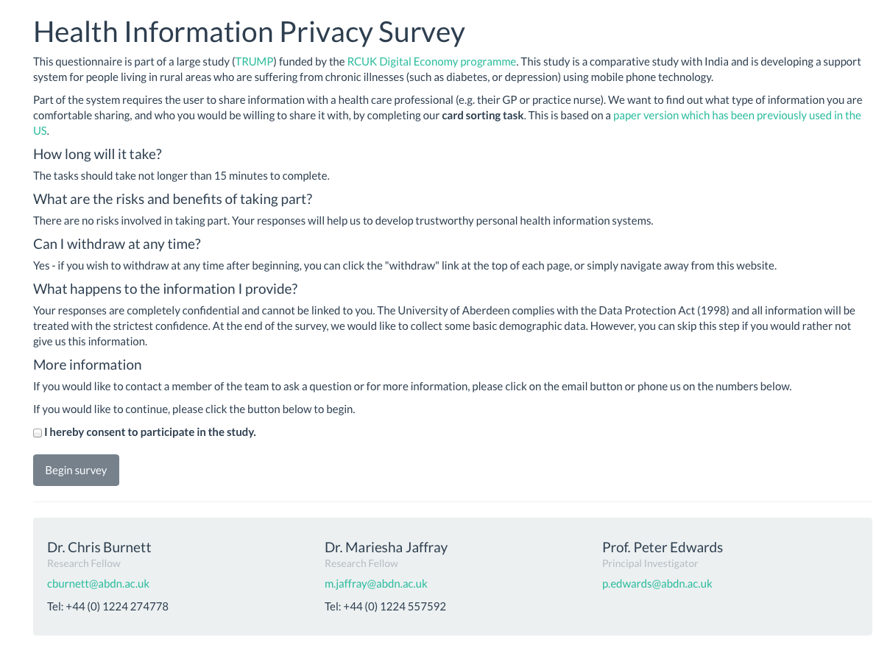

Figure 1: Consent gathering screen

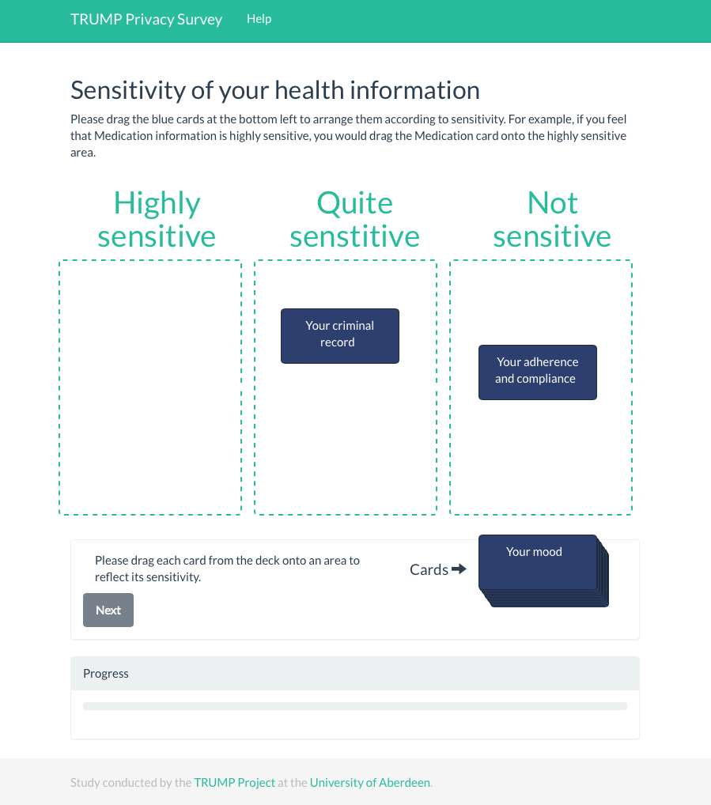

Figure 2: Card sorting task

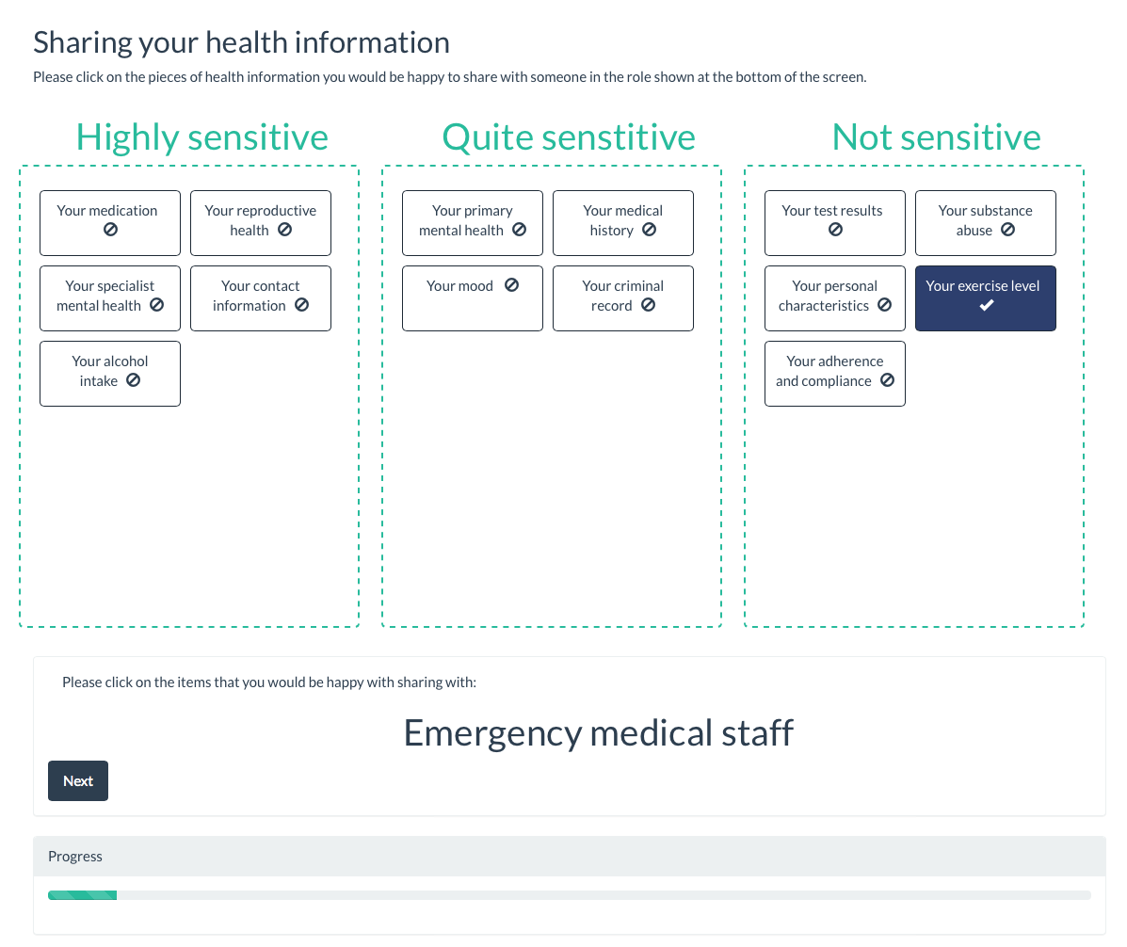

Figure 3: Sharing preference screen

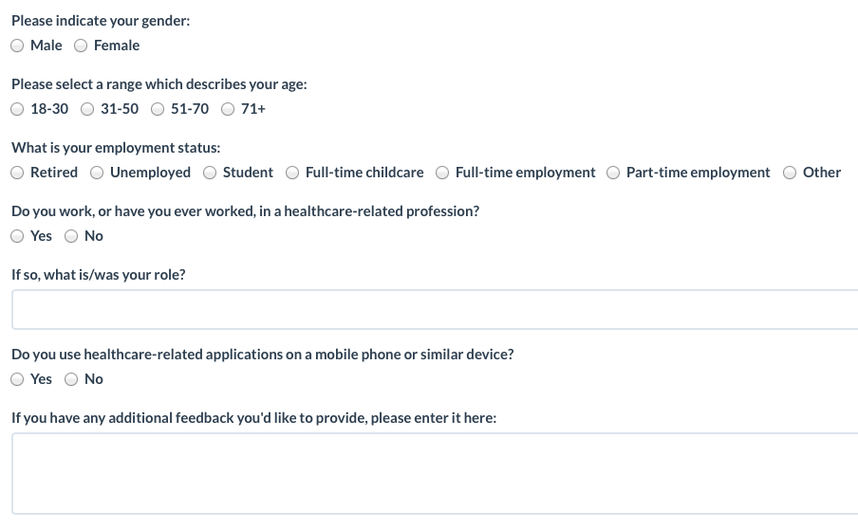

Figure 4: Final demographic questionnaire

# References

[1] Burnett, C., Edwards, P., Norman, T. J., Chen, L., Rahulamathavan, Y., Jaffray, M., & Pignotti, E. (2013). TRUMP: A Trusted Mobile Platform for Self-management of Chronic Illness in Rural Areas. In *Trust and Trustworthy Computing* (pp. 142-150). Springer Berlin Heidelberg.

[2] Caine, K., & Hanania, R. (2013). Patients want granular privacy control over health information in electronic medical records. *Journal of the American Medical Informatics Association*, *20*(1), 7-15.